|  |
| --- |
| **AITSE 0312** |

**NATIONAL TEACHERS COUNCIL**

**ALL INDIA TALENT SEARCH EXAMINATION: 2012**

**CLASS III**

**Duration: 90 Minutes Maximum Marks: 70**

***General Instructions to Candidates***

*1. This question paper contains 70 multiple choice questions each of one mark.*

*2 The question paper is divided into two sections,* ***A*** *and* ***B.***

*3. Section* ***A*** *is* ***S****cholastic* ***A****ptitude Test**(****SAT)****, contains 40 questions. This section covers* ***Environmental Science*** *and* ***Mathematics****.*

*4. Section* ***B*** *is* ***M****ental* ***A****bility* ***T****est* ***(MAT),******C****omputer* ***A****wareness**and* ***G****eneral* ***K****nowledge****,*** *contains 30 questions.*

*5. There will be no negative marks for wrong answer.*

*6. A separate answer sheet is provided for answering the questions. Each question should be answered by* ***darkening*** *the appropriate circle (A, B, C, or D) with a* ***blue or black ball pen****.*

*7. Answer recorded once in the answer sheet cannot be altered.*

*8. All rough works should be done only in the space provided for* ***rough work*** *in this question paper.*

*9. Calculator is not permitted in the examination hall.*

*10. Candidate should write his / her name in the space provided for the purpose.*

|  |  |  |  |  |  |  |  |  |  |  |  |  |  |  |  |  |  |  |  |
| --- | --- | --- | --- | --- | --- | --- | --- | --- | --- | --- | --- | --- | --- | --- | --- | --- | --- | --- | --- |
| Name |  |  |  |  |  |  |  |  |  |  |  |  |  |  |  |  |  |  |  |

**SECTION A**

1. The smallest planet of the solar system

A) Mercury B) Pluto C) Venus D) Mars

2. Green plants can prepare their own food in presence of sunlight. The raw material used by plants for this process

A) Oxygen & Water B) Oxygen & Carbon dioxide

C) Carbon dioxide & Water D) Water & Fertilizers

3. The largest terrestrial animals

A) Blue whale B) Elephant C) Ostrich. D) None of these

4. We can see the complete bright disc of the moon on a full moon day and no moon on a new moon day. On which day the moon comes in between the sun and the earth

A) New moon day B) Full moon day C) Both (A) & (B) D) None of these

5. Miss Kaveri adds lots of **green leaves and vegetables** in their food. She will grow

A) Fat & round B) Strong & muscular

C) Healthy & disease free D) All of these

6. Food which is a rich source of **Vitamin A** is

A) Apricot B) Broccoli C) Bread D) Liver

7. We use different devices to measure different physical quantities. The device lactometer is used to measure

A) Purity of milk B) Earthquake C) Temperature D) Humidity of air

8. A world famous Indian Agricultural Scientist

A) S. Chandrasekhar B) C. V. Raman C) J. C. Bose D) M. S. Swaminathan

9. The proper knowledge of first aid helps to save the life of people at the time of accident. What first aid would you give for burn injury?

A) Pulls away the burnt clothes from the body

B) Pour cold water on the burnt part of the body

C) Use ointment or lotion on the burnt part

D) Break or prick blisters on the burnt part

10. Which of the following method makes food more nutritious?

A) Sprouting B) Fermentation C) Salting D) Baking

11. An animal that has spines to defend from its enemies

A) Platypus B) Tortoise C) Chameleon D) Porcupine

12. Identify the one which is classified wrongly

|  |  |  |
| --- | --- | --- |
| Options | Plant Product | Animal Product |
| **A** | Cotton | Silk |
| **B** | Jute | Leather |
| **C** | Wool | Paper |
| **D** | Rubber | Honey |

13. Cactus is a desert plant. To minimize loss of water it does not have leaves. The stem is green and waxy and prepares food for the plant. This shows that

A) Wax is obtained from Cactus B) Plant modifies according to habitat

C) Habitat change according to plant D) Cactus is insectivorous in nature

14. The roots of plants have various functions. Which among the following is not a function of the roots?

A) Production of food B) Storage of food C) Support D) Absorption of water

15. Which one of the following is NOT a food chain?

A) Grass Grass hopper Frog Snake

B) Fly Frog Snake Eagle

C) Plant Rabbit Tiger

D) Egg Larva Pupa Butterfly

16. In the night sky stars appear to move from east to west, because

A) Earth revolves from west to east

B) Earth revolves from east to west

C) Stars revolves around the earth from east to west

D) Stars revolves around the earth from west to east

17. Carefully observe the flow chart given below:-

**P R**

**WATER VAPOUR**

**WATER**

**ICE**

**Q S**

Which one of the following is true for P, Q, R and S?

A) P & Q are heating, R & S are cooling B) P & S are heating, Q & R are cooling

C) P & R are heating, Q & S are cooling D) P & R are cooling, Q & S are heating

18. The animals, cow, goat and sheep are similar because, they are

A) Herbivorous B) Carnivorous C) Insectivorous D) Omnivorous

19. Which of the following organ help to purify blood in our body?

A) Lungs B) Heart C) Kidney D) Liver

20. Which is NOT a sense organ?

A) Eye B) Tongue C) Skin D) Hand.

21. How many months in a year have 30 days?

A) 8 B) 7 C) 5 D) 4

22. The difference between smallest four digit number and largest two digit number is

A) 901 B) 999 C) 99 D) 1

23. How many times minute hand moves round the clock in a day?

A) 60 B) 3600 C) 24 D) 120

24. Identify the missing number in the following:

**509 = 5 x 100 + x 10 + 9 x 1**

A) 1 B) 0 C) 9 D) 50

25. Janani has 22 marbles with her. How many more marbles are required to make it 50?

A) 72 B) 30 C) 28 D) None of these

26. 5 hundreds + 16 tens + 2 one is equal to

A) 662 B) 516 C) 562 D) 212

27. A closed figure made up of three line segments of equal length

A) Rectangle B) Square C) Circle D) Triangle

28. The place value of 8 in **78945** is

A) Eighty thousand B) Eight thousand

C) Eight hundred D) Eight thousand nine hundred

29. Write the fraction representing the shaded portion in the figure:

|  |  |  |  |
| --- | --- | --- | --- |
|  |  |  |  |
|  |  |  |  |
|  |  |  |  |

A) $\frac{3}{12}$ B) $\frac{3}{9}$

C) $\frac{3}{4}$ D) None of these

30. Suresh purchased 12 eggs for Rs. 48. What is the cost of 2 eggs?

A) Rs. 4 B) Rs. 8 C) Rs. 4.8 D) Rs 12

31. The sum of two numbers is 1000 and their difference is 998. The numbers are

A) 1000 & 998 B) 998 and 999 C) 999 and 1 D) None of these

32. Find the number that makes the given equation true.

**?**

÷ 9 = 12

A) 18 B) 63 C) 81 D) 108

33. If represents 5 and represents 4, then

+ is equal to

A) 9 B) 40 C) 20 D) 81

34. The expanded form of **12701** is

A) 10000 + 2000 +700 +10 + 1 B) 10000 + 1000 + 100 +10 + 1

C) 10000 + 2000 +700 +0+ 1 D) 10000 + 2000 +100 +0 + 1

35. Sahil has 12 red , 7 blue and 5 green pens. What fraction of the pens is red?

A) B) C) D)

36. The smallest five digit number that can be formed with digits 4, 7, 9 and 3 is

A) 3497 B) 3749 C) 3479 D) 9743

37. The sum of 23 hundreds and 53 tens is equal to

A) 2 thousand + 8 hundred + 30 tens B) 76 hundreds

C) 2 thousand + 56 hundred D) 2 thousand + 8 hundred + 3 tens

38. The difference between three-fourth and half is

A) Half B) One-fourth C) Two –fourth D) One-eighth

39. 14 + (6 + 18) = ( 14 + -------) + 18

A) 6 B) 18 C) 14 D) 0

40. Which is not the same as 5 X 6?

A) 6 + 6 + 6 + 6 +6 +6 B) (4+2) x 5

C) 6 + 5 D) (3 +2) x 6

**SECTION B**

41. Which one of the following is not an input device?

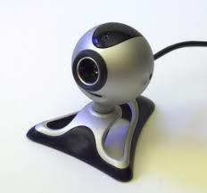 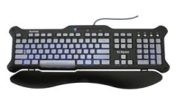 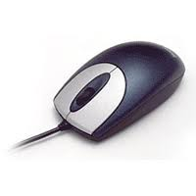 

A) B) C) D)

42. Which one of the following tool is used for erasing a picture in paint?

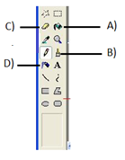

43. What is the function of an ***Enter Key?***

A) To move next line B) To give space

C) To type capital letters D) To type symbols

44. Identify the icon on Desktop which is used to brows Internet.

**[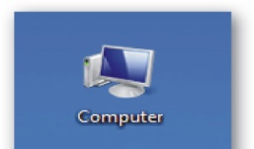](http://s47.photobucket.com/albums/f172/hdnt/?action=view&current=mycomputervistaicon.jpg)[](http://4.bp.blogspot.com/_L3HMnpA1zmk/TTgn0mKPu3I/AAAAAAAAATg/xS4OBpojB7o/s1600/recycle-bin.png)  **

A) B) C) D)

45. Which one of the following program disturbs the normal function of a computer?

A) Games B) Virus C) Arithmetical D) Painting

46. Which one of the following is not correctly matched?

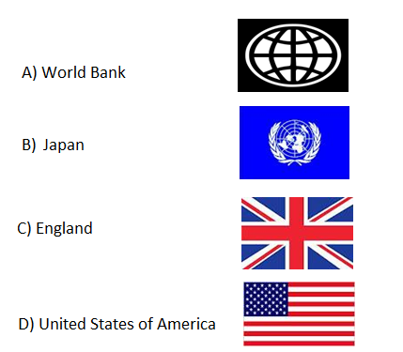

47. Who among the following was not our Prime Minister?

A) Narasimha Rao B) L K Advani

C) Jawaharlal Nehru D) Manmohan Singh

48. Which one of the following is not a Union Territory of India?

A) Goa B) Andaman and Nicobar

C) Lakshadweep D) Chandigarh

49. Which is the smallest country in the world?

A) Nauru B) Peru

C) Israel D) Vatican City

50. Who is the present president of India?

A) Prathiba Patil B) A K Antony

C) Manmohan Saingh D) Pranab Mukharjee

51. Identify this great ruler of Mysore.

A) Hyder Ali

B) Tipu Sultan

C) Shivaji

D) aurangazeb

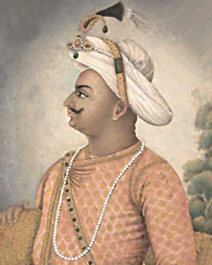

52. What is the importance of Vasco - da - Gama in Indian history?

A) He is the first European reached to India

B) He discovered new sea route to India

C) He established trade with India

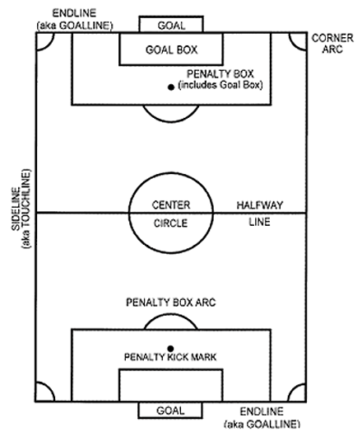 D) He attacked India

53. Which game is associated with the following ground?

A) Football

B) Basketball

C) Volleyball

D) Cricket

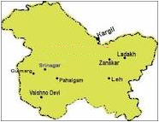54. Identify this state of India.

A) Madhya Pradesh

B) Jammu and Kashmir

C) Uttar Pradesh

D) Gujarat

55. Name the largest sea in the world.

A) China sea B) Caspian sea

C) Arabian Sea D) Mediterranean Sea

56. Find the odd one out:

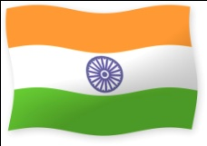 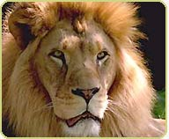 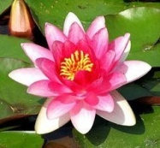 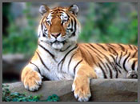

A) B) C) D)

57. Find the odd one out:

A) B) C) D)

58. Find the odd one out

   

A) B) C) D)

59. Find the odd one out:

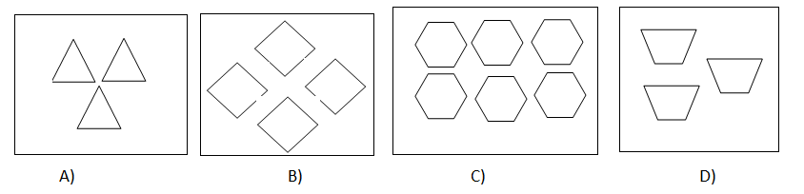

60) Find the odd one out:

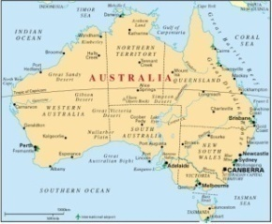 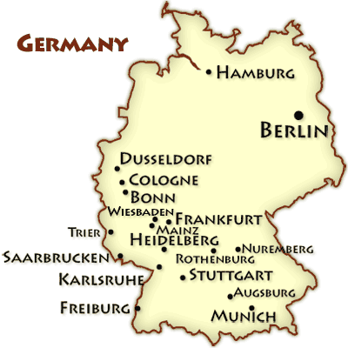 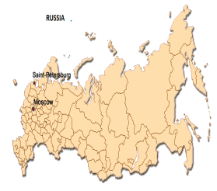 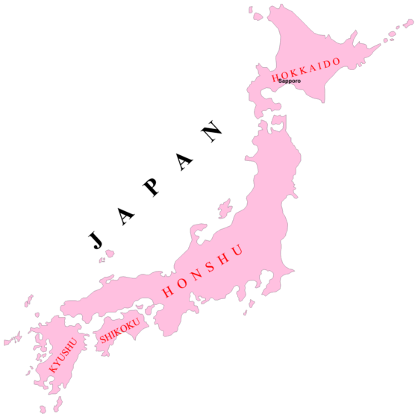

A) B) C) D)

61. Replace the question mark:

?

25

9

16

4

1

A) 50 B) 75 C) 36 D) 49

62. Replace the question mark:

2

1

1

2

4

5

1

3

3

?

5

12

A) 14 B) 15 C) 16 D) 17

63. Replace the question mark: A) 72

B)82

C)90

D)80

64. Replace the question mark:

?

I

E

G

C

A

A) J B) K C) L D) M

65. Replace the question mark:

?

Q

L

H

E

C

A) S B) T C) W D) X

66. 33 + 33 + 33 + 33 + 33 = ------ X 33

A) 5 B) 3

C) 4 D) 2

67. When a number passes through a box, a different number comes out. If 2 goes in 4 comes out, if 3 goes in 9 comes out, if 4 goes in 16 comes out. If 5 go in, which number will be coming out?

A) 25 B) 15

C) 50 D) None of these.

68. In a certain code CLASS III is written as III SSALC. How is CLASS II written in that code?

A) II CLASS B) II SSCLA

C) II ALCSS D) II SSALC

69. Raju walks 50m towards north and turns his right and walks. Now which direction he is facing?

A) East B) West

C) North D) South

70. Which one of the following player is associated with badminton?

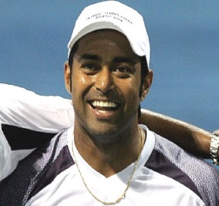 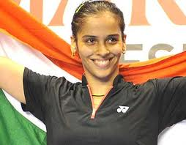 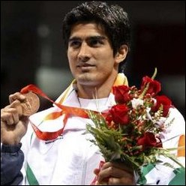 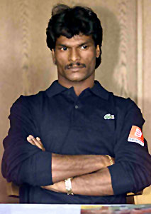

A) B) C) D)

***Space for Rough Works***